DMDW LAB – 3

AIM: Demonstrate performing Apriori on data sets

THOERY:

The Apriori algorithm is an influential algorithm for mining frequent item sets for Boolean association rules. It uses a “bottom-up” approach, where frequent subsets are extended one at a time (a step known as candidate generation, and groups of candidates are tested against the data).

**Problem:**

TID ITEMS

100 1,3,4

200 2,3,5

300 1,2,3,5

400 2,5

To find frequent item sets for above transaction with a minimum support of 2 having confidence measure of 70% (i.e, 0.7).

**After using the Apriori algorithm , the rules would be:**

{2,3}=>{5}, {3,5}=>{2}, {1}=>{3},{2}=>{5}, {5}=>{2}.

Steps to perform on WEKA:

Step1: Make a dataset describing the info. Given in the table about the item and its frequency.

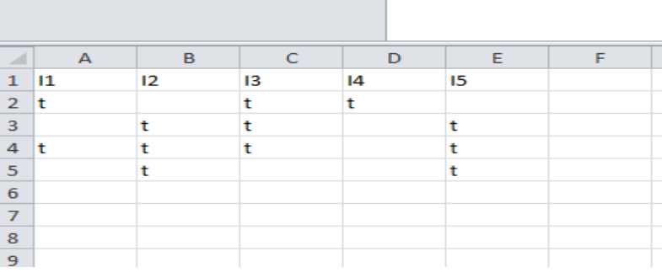

Step2: Open weka explorer and open the file and then select all the item sets.

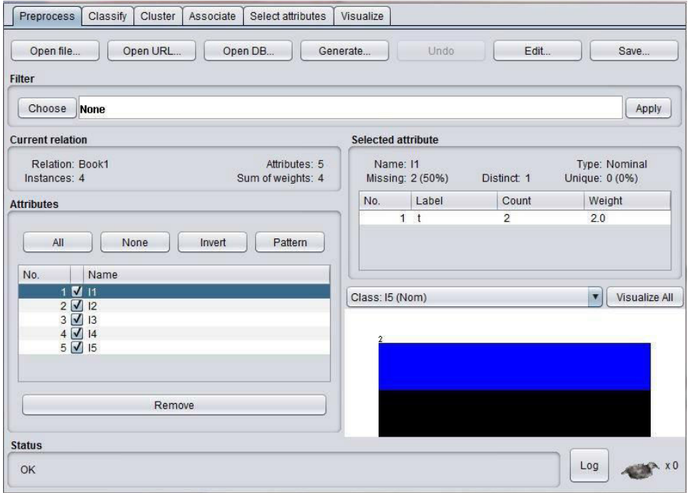

Step3: Select the association tab and then choose apriori algorithm by setting the minimum support and confidence.

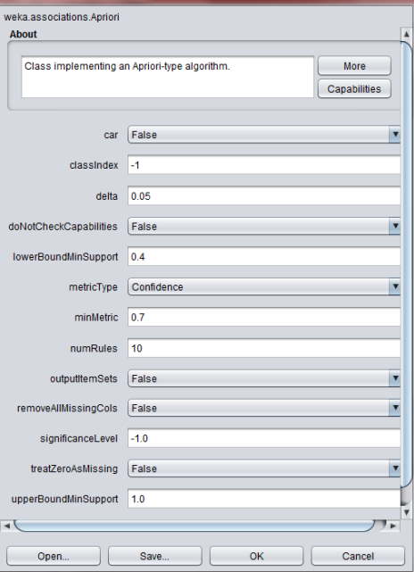

Step4: Run the apriori algorithm with the set values of minimum support and the confidence. After running the weka generates the association rules and the respective confidence with minimum support.

The results generated are:

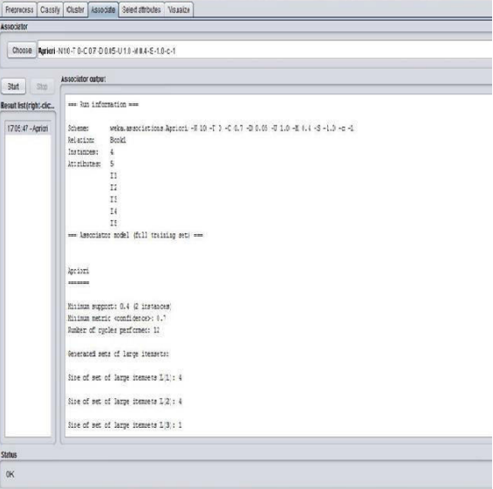

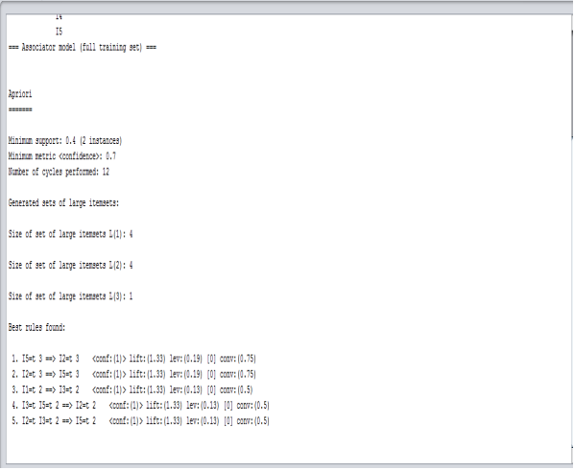

CONCLUSION:

Successfully implemented Apriori algorithm using the WEKA tool to find the association rules.